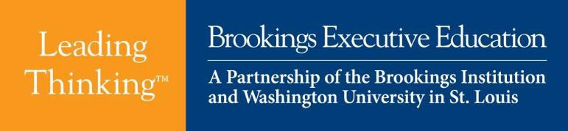

Strategic Communication and Negotiations



## September 28-29, 2016 Tampa, FL

Communications become strategic when they are placed at the center of forging collaborative

relationships and negotiating practical solutions. This program introduces new thinking, based on leading research, on how to maximize the likelihood of influencing others by introducing a three step process. The first step involves developing a deep understanding of existing interactions from the other person’s perspective. The second step develops the habit of communicating in a purposeful and strategic manner in the service of accomplishing goals. The third step develops a deep appreciation for how potential audiences make sense of communication from their cultural perspectives.

In discussing these three steps, participants will develop insights into why they have succeeded or failed in communicating in the past, as well as learn practical techniques for maximizing the likelihood of succeeding in the future. The course will introduce several important, yet underappreciated topics about the dynamics of negotiation across cultural differences that can greatly affect outcomes. The course is designed to prepare participants to become better negotiators in complex cross-cultural business and conflict resolution contexts and develop skills that can manage or prevent conflict. It also presents an introduction to cross-cultural conflict resolution—especially in conflict zones—with an in-depth practitioner’s case. Specific attention is given to religion, tribalism, ethnicity, language, race, and gender, which is necessary to developing a comprehensive approach.

Participants will accumulate new knowledge, insights, and thinking that will help them meet the 21st century challenge of strategic communication and negotiations.

## Two-Day Program Learning Objectives:

* Understand your communication style
* Define and practice conscious communication
* Learn how to build successful collaborative relationships
* Understand the differences between cross-cultural international negotiations and traditional negotiations
* Understand the dynamics of international negotiations and conflict resolution, and examine how culture can impact the outcomes
* Learn how to choose and apply negotiating tools

# Day One: Wednesday, September 28 Strategic Communication

## 7:30 – 8:00 AM Program Registration, Breakfast and Networking

**8:00 – 8:45 AM Welcome, Introduction, and Overview**

Welcoming remarks by Lieutenant General Martin Steele (Retired) – Instructors: Eric M. Eisenberg, Ph.D., Dean and Professor of Communication, College of Arts and Sciences, University of South Florida; and Adib Farhadi, Ph.D., Research Assistant Professor, University of South Florida.

Course Objectives and Participant Expectations

## 8:45 – 9:45 AM Defining Strategic Communication

**9:45 *–* 10:00 AM Break**

## 10:00 *–* 11:00 AM Understanding your communication style

**11:00 *–* 11:05 AM Break**

## 11:05 *–* 12:00 Understanding your communication style (cont.)

**12:00 *–* 1:00 PM Lunch**

## 1:00 *–* 2:15 PM Collaborating across differences; systematic stakeholder analysis 2:15 *–* 2:30 PM Break

**2:30 *–* 3:30 PM Promoting positive dialogue 3:30 *–* 3:35 PM Break**

**3:35 *–* 4:00 PM Review and Reflection on Days Learnings; Transition to Day Two Objectives**

**Day Two: Thursday, September 29 Strategic Negotiations**

**7:30 – 8:00 AM Breakfast, networking**

**8:00 – 8:30 AM Welcome back; nuggets; objectives for today**

Welcome back by Lieutenant General Martin Steele (Retired) – Instructors: Adib Farhadi, Ph.D., Research Assistant Professor, University of South Florida and Lieutenant COL Colonel Scott Mann (Retired)

## 8:30 – 9:45 AM The process of strategic negotiations – the fundamentals 9:45 – 10:00 AM Break

**10:00 – 11:00 AM Cross-­‐Cultural Negotiations – application 11:00 – 11:05 AM Break**

**11:05 – 12:00 AM Cross-­‐Cultural Negotiations – application (cont.) 12:00 – 1:00 PM Lunch**

**1:00 – 2:30 PM Lieutenant COL Colonel Scott Mann (Retired) -­‐ *Guest Speaker***

**Case Study 1: Engaging with Department of State Case Study 2: Village Stability Operations**

**2:30 – 2:45 PM Break**

**2:45 – 3:30 PM Cultural Intelligence to address difficult situations**

**3:30 – 3:35 PM Break**

**3:35 – 4:00 PM Review and Reflection, key takeaways**